Data Scraping - MARINAS ireland

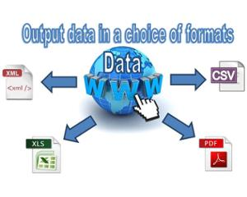



Product Design Specification

Version *<1.0>*

*04/12/2015*

VERSION HISTORY

|  |  |  |  |  |  |
| --- | --- | --- | --- | --- | --- |
| **Version #** | **Implemented**  **By** | **Revision**  **Date** | **Approved**  **By** | **Approval**  **Date** | **Reason** |
| 1.0 | *Sandra Couch* | *04/12/2015* | *Paul Stynes* | *<mm/dd/yy>* | Initial Design Definition draft |
|  |  |  |  |  |  |
|  |  |  |  |  |  |

**UP Template Version:** 12/31/07

TABLE OF CONTENTS

1 Introduction 5

1.1 Purpose of The Product Design Specification Document 5

2 General Overview and Design Guidelines/Approach 5

2.1 Assumptions / Constraints / Standards 5

3 Architecture Design 5

3.1 Logical View 5

3.2 Hardware Architecture 5

3.3 Software Architecture 5

3.4 Security Architecture 5

3.5 Communication Architecture 5

3.6 Performance 6

4 System Design 6

4.1 Use-Cases 6

4.2 Database Design 6

4.3 Data Conversions 6

4.4 Application Program Interfaces 6

4.5 User Interface Design 6

4.6 Performance 6

4.7 Section 508 Compliance 6

Appendix A: References 7

Appendix B: Key Terms 8

# Introduction

## Purpose of The Product Design Specification Document

The purpose of this application is to scrape data from Websites where Hotels are listed and display this information in a mobile application for Marinas Ireland.

The Product Design Specification document documents and tracks the necessary information required to effectively define architecture and system design in order to give the development team guidance on architecture of the system to be developed. The Product Design Specification document is created during the Planning Phase of the project. Its intended audience is the project manager, project team, and development team. Some portions of this document such as the user interface (UI) may on occasion be shared with the client/user, and other stakeholder whose input/approval into the UI is needed.

# General Overview and Design Guidelines/Approach

This section describes the principles and strategies to be used as guidelines when designing and implementing the system.

## Assumptions / Constraints / Standards

# Architecture Design

This section outlines the system and hardware architecture design of the system that is being built.

## Logical View

## Hardware Architecture

## Software Architecture

## Security Architecture

## Communication Architecture

## Performance

# System Design

## Use-Cases

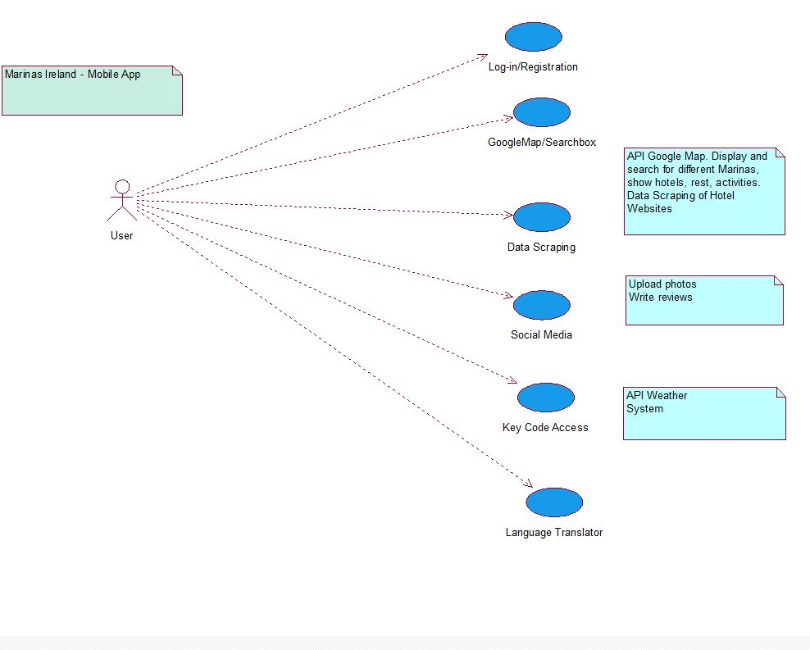

Data Scraping Use Case

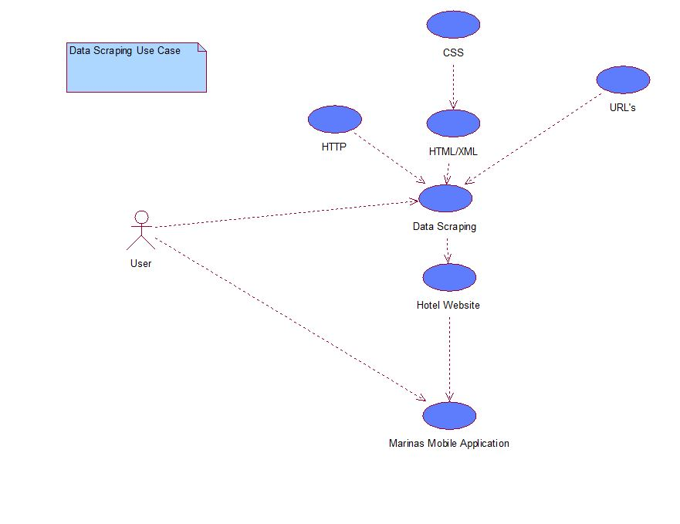

**Use Case Diagram**

**LOG-IN/REGISTRATION**

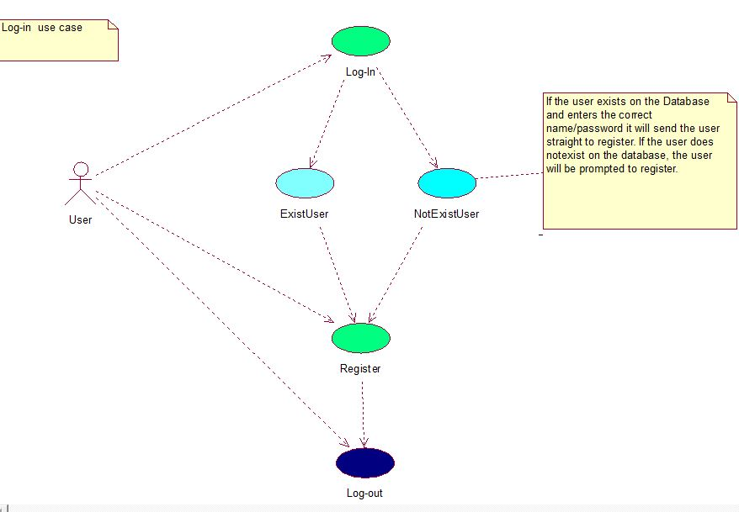

**Use Case Diagram – Google Maps**

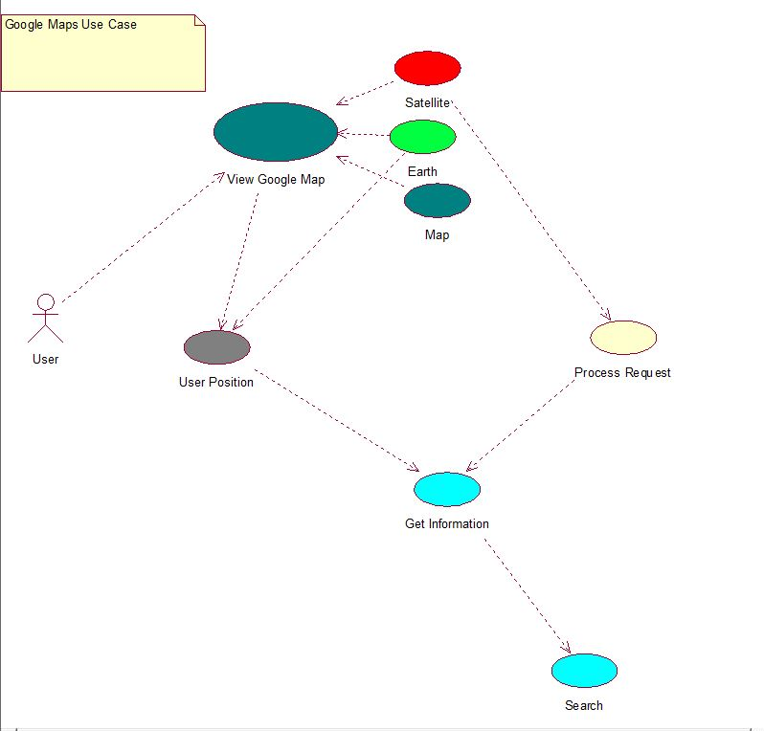

**Use Case Diagram - Social Media**

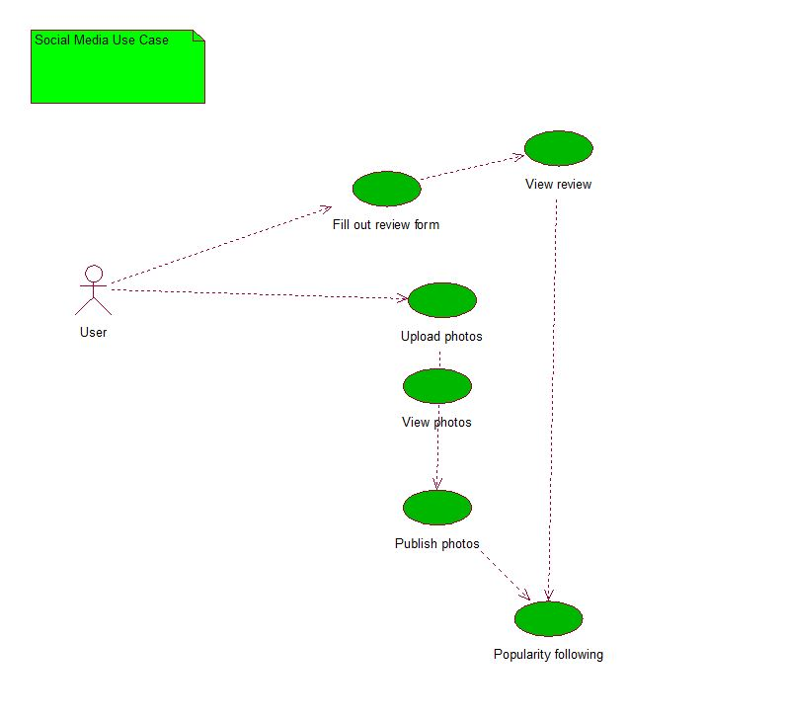

**Use Case Diagram – Key Code Access**

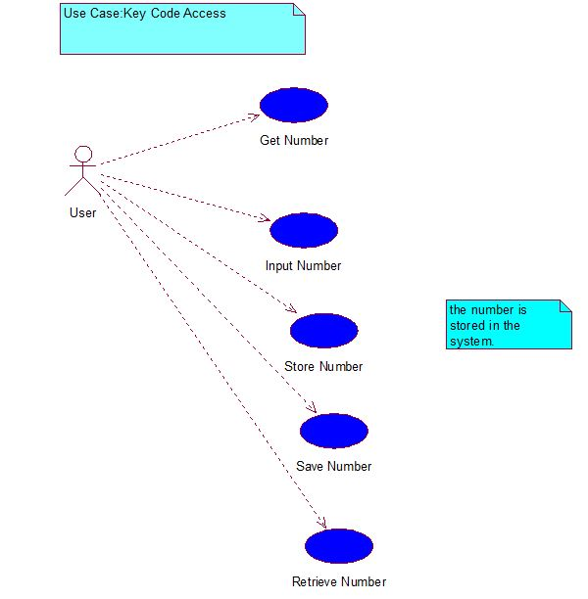

**Use Diagram – Language Translator**

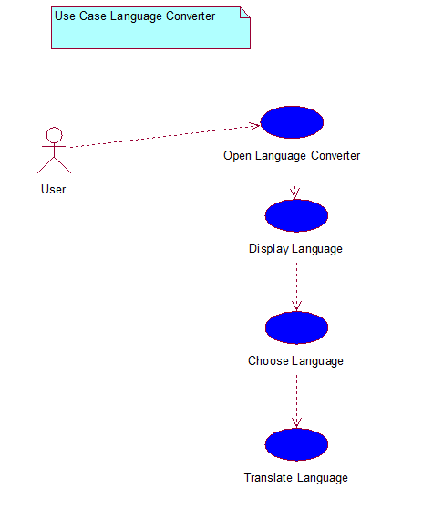

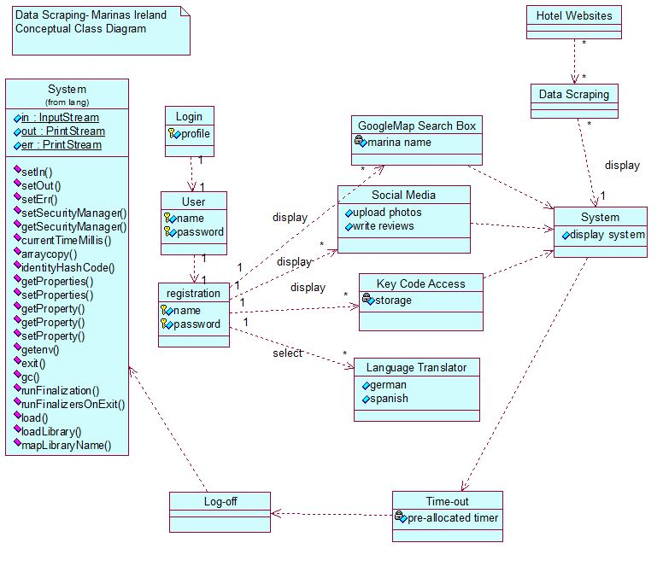

Database

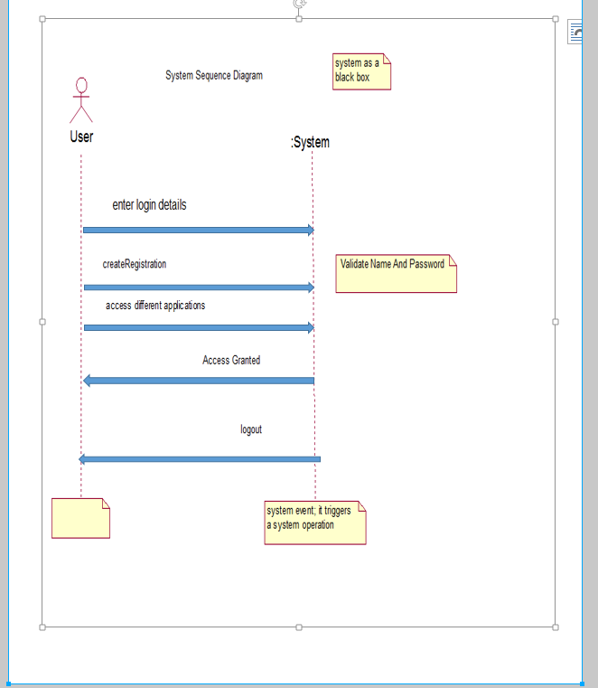

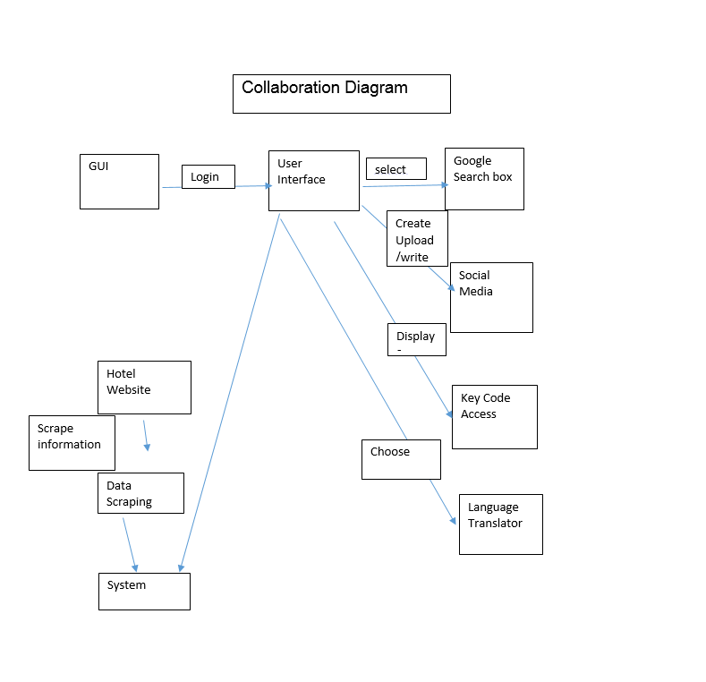

Database

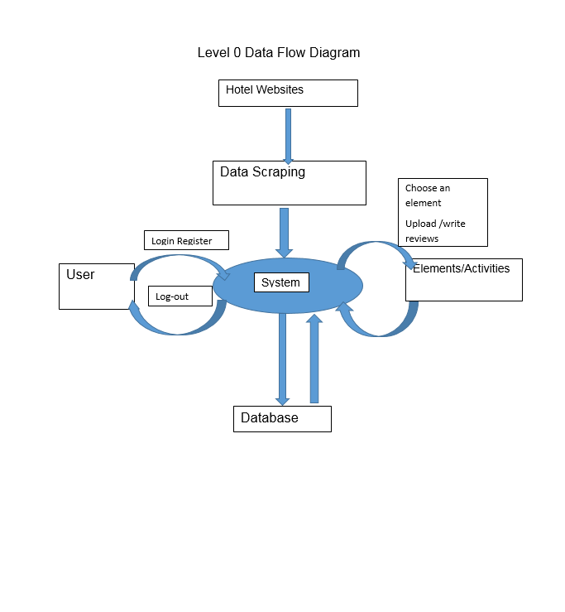

## Database Design

# Image result for image database

## Image result for image database

Data Scraping

## Data Conversions

## Application Program Interfaces

## User Interface Design

Google API

Weather Map API

Language Translator

Data Scraping

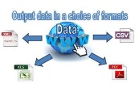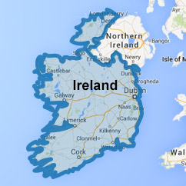

Data Scraping from Hotel Websites On to Marinas Ireland Website



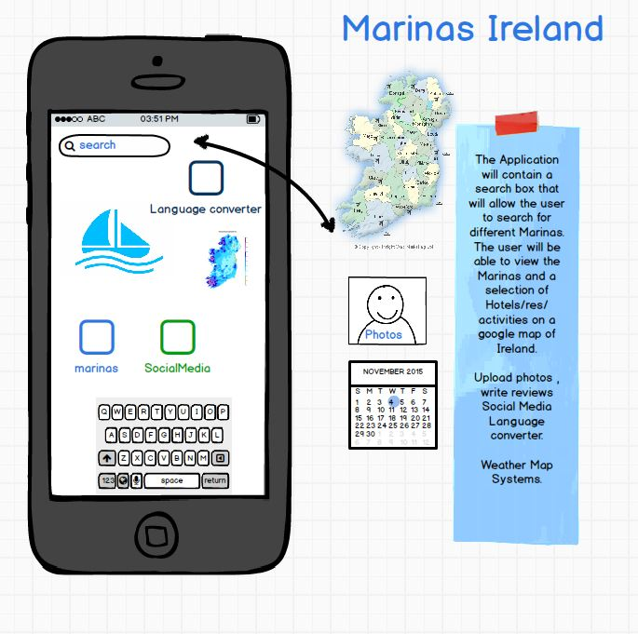

## Performance

## Section 508 Compliance

Appendix A: References

Lecture notes by Mr. Paul Stynes for Class Diagrams, Interaction Diagrams,

Semester Two Examinations 2102/2013 Software Engineering (Solutions) Mr. Paul Stynes, Mr. Tom Nolan

The following table summarizes the documents referenced in this document.

|  |  |  |
| --- | --- | --- |
| **Document Name and Version** | **Description** | **Location** |
| *Post Case Study Design Phase*  *Class Diagrams*  *Interaction Diagrams*  *Software Engineering2 UML* | *Lecture Notes.*  *Lecture Notes*  *Lecture Notes*  *2102/2013* | *Mr. Paul Stynes*  *Mr. Paul Stynes*  *Mr. Paul Stynes*  *Mr.Paul Stynes, Mr. Tom Nolan* |